Educational Management for Unity and Peace in ASEAN Community: Research into Practice

Assoc. Prof. Dr. Phra Theppavaramethi
Dr.Lampong Klomkul
Mahachulalongkornrajavidyalaya University, Thailand

Abstract
Educational management for unity and peace in ASEAN community was presented in this article. It is the development of research into practice. The purposes were to develop strategy of educational management for the unity, and to propose trends of educational management for peace in ASEAN community. Future Research using Ethnographic Delphi Future Research (EDFR) was designed and the target group was educational personnel from ten ASEAN countries. Research tools were interview schedule and questionnaires. Qualitative data were analyzed by using content analysis and analytic induction, and quantitative data from EDFR questionnaires were analyzed using median, mode and interquartile range as descriptive statistics. Results were showed as follows: six strategic aspects of educational management for unity in ASEAN were synthesized which consisted of strategy 1 develop teachers and administrators, strategy 2 collaborate curriculum and assessment, strategy 3 enhance teaching and instruction, strategy 4 encourage educational research, strategy 5 facilitate educational opportunity, and strategy 6 develop educational management. The scenario of ASEAN education roadmap is to predict the future of education that to move towards education cooperation in 2018, to be a unity in education in 2020, to have education for peace in 2022, and to make ASEAN community full of unity and peace of education in 2024.
Keywords: Educational Management, Unity and Peace, ASEAN Community

Introduction
The preparation for the readiness into ASEAN community at the end of year 2015 was a very important role for every organization that they needed to prepare for the change in order to be a part of ASEAN community. Educational organization is also needed to prepare for the readiness as well. Modern education and information technology are needed for helping to enhance level of education into international standard especially 7 occupations that have freely movement between countries within ASEAN community. These seven occupations are doctor, dentist, nurse, engineer, architect, explorers, and accountant. Therefore, the preparation of basic education to students is very important to train their learning skills for the quality of their future occupations. The learning activity that will meet the target of students’ achievement should be designed in variety and diversity and should cover 5 learning aspects which are 1) cognitive domain 2) affective domain 3) psycho-motor domain 4) process skills, and 5) integration. These aspects or skills of learning activities are usually used in general and worldwide (Khaemanee, T., 2007; Editorial department of Wittayajarn Journal, 2011).
The main purpose of educational management in ASEAN community has related to the fifth main objective of ASEAN which is to encourage each other to train and conduct research, support South East Asia education, and create awareness and understanding between people by using knowledge sharing in education.
Educational management is also related to the third pillar of ASEAN community which called the ASEAN Socio-Cultural Community. Therefore, the purpose of setting ASEAN community is to create the unity and co-operation in the region which will provide the opportunity for all countries to increase sharing of usefulness and encouragement to each other instead of having a competition (Piboonsongkram, P., 2011; Department of strategy and evaluation Bangkok, 2013).
Many organizations in each country have prepared for the readiness of entering ASEAN community in 2015 especially the organization that related to educational management. Some countries have issued planning approach and educational development was set for the strategy in order to develop education for produce qualify labors for team working of countries in ASEAN community. Brunei is one of the countries that having encouragement of students in vocational education to have an efficiency and matches with seven occupations. Philippines is also awakened to study and research in action by using good role of model to be the pattern of doing learning activities as well as Indonesia. Moreover, planning of educational management for the readiness of entering ASEAN community is also happening in Singapore, Cambodia, Malaysia, and Thai (Department of Technical Education, 2008; Ministry of Education, 2012; The World Bank, 2014; Florido, A.M., 2014; Ministry of Education, 2014).
From the state of educational management of countries in ASEAN community that occurs in the present still appear some different aspects. In the aspect of teacher development, Singapore has shown good practice and being good role of model in teacher development for many countries in ASEAN region and world level. Many countries in ASEAN start to use the innovation and system of teacher development from Singapore; however, the effectiveness of development is still far away from Singapore. Even though in Thailand, the innovation and teacher development still keeps on going for the readiness and equality of teacher development in ASEAN community (Pornsrima, D., 2013). Student’s development is also needed for enhancing the equality of producing qualify labors in ASEAN countries.
Organizations are alert for the adjustment and plan in educational management for the readiness of entering ASEAN community in 2015. Previous educations caused to current education and continue to future education. Therefore, setting of trends and possible standard is the way for social development in holistic of ASEAN community which will be the network interaction for increase sharing and connection. It is important to set the trend of educational management systematically and be the unity which will toward to the holistic of ASEAN society. However, the composition of educational management needs to have working system in many levels. It starts from policy level or plans in the country level. Level of curriculum development and level of learning and instruction are planned in all countries in order to prepare for entering ASEAN community. Each country will plan and issue their own policy, but it does not have any plan to collaborate for the unity in ASEAN community.
Therefore, this article interested in studying and developing trends and possibility of educational management for the unity of countries in ASEAN community including to live peaceful coexistence in society. The purposes were to propose the state of educational management in ASEAN community, to develop framework of educational management for the unity in ASEAN community, and to propose trends and set strategy of educational management for peace of countries in ASEAN. Future Research using Ethnographic Delphi Future Research (EDFR) was designed and the target group was educational personnel from ten ASEAN countries. Research tools were interview schedule and questionnaires. Qualitative data were analyzed by using content analysis and analytic induction, and quantitative data from EDFR questionnaires were analyzed using median, mode and interquartile range as descriptive statistics. Results of educational management for unity and peace in ASEAN community were presented in this article as the following topics. Eight parts of this article are shown which consisted of 1) introduction, 2) purposes, 3) methodology, 4) results, 5) reflections, 6) results of study into practice, 7) lesson learned, and 8) conclusion. A detail of each part is shown in the next topics.

The purposes of this research
There were two purposes as follows:
1. To develop strategy of educational management for the unity.
2. To propose trends of educational management for peace in ASEAN community.

Research Methodology
Future Research using Ethnographic Delphi Future Research (EDFR) was designed and the target group was educational personnel from ten ASEAN countries. Research tools were interview schedule and questionnaires. Qualitative data were analyzed by using content analysis and analytic induction, and quantitative data from EDFR questionnaires were analyzed using median, mode and interquartile range as descriptive statistics.

Results
1. Strategy of Educational Management for Peace in ASEAN Community
For the strategy of educational management for peace in ASEAN community, it indicated that six strategic aspects were synthesized consisted of strategy 1 develop teachers and administrators, strategy 2 collaborate curriculum and assessment, Strategy 3 enhance teaching and instruction, strategy 4 encourage educational research, strategy 5 facilitate educational opportunity, and strategy 6 develop educational management and showed as below figure.

Figure 1 ASEAN Education Strategic Plan
2. Goals of Education Startegy
The analysis results from Ethnographic Delphi Future Research (EDFR) technique collected from 27 experts indicated that 6 strategies and 26 goals have been accepted the consensus from experts all items. Considering median, median and mode difference and interquartile range of each item showed that median of strategies and goals was between 4.00 to 5.00, the absolute of median and mode difference equal to 0 in all items, interquartile range were between 0.00 – 1.00 which showed that the expert group had correlated agreement on ASEAN education strategic plan at agree level to strongly agree level. Considering goals in each strategy showed as below:
Three goals are set for the 1st strategy to develop teachers and administrators, which are 1) develop teachers and lecturers to be professionalism, 2) develop Educational administrators to be professionalism, and 3) develop educational personnel to have accountability.
Four goals are set for the 2nd strategy to collaborate curriculum and assessment, which are 1) develop the basic education curriculum for all, 2) enhance curriculum diversification with ASEAN standards, 3) continue the comprehensive reform of educational assessment, and 4) collaborate curriculum and assessment between ASEAN countries.
Five goals are set for the 3rd strategy to enhance teaching and instruction, which are 1) enhance teaching and instruction with efficiency and innovativeness, 2) enhance the quality of learning and teaching effectively, 3) integrates technology through teaching and instruction excellently, 4) encourage cross cultural learning between each ASEAN country, and 5) encourage a personalized learning to achieve 21st century competencies.
Four goals are set for the 4th strategy to encourage educational research, which are 1) increase associate training scientific research for social needs, 2) conduct research for improving the quality of teaching and learning, 3) conduct research and implement from educational system into the community, and 4) develop educational innovation for improving student’s learning through classroom action research.
Five goals are set for the 5th strategy to facilitate educational opportunity, which are 1) support compulsory and inclusive education, 2) expand access to preschool services for children in rural areas, 3) increased attention to the education and training needs of adults, 4) provide the opportunity to fulfill student’s potential regardless of background, and 5) increase scholarships and opportunities for poor and merit students.
Five goals are set for the 6th strategy to develop educational management, which are 1) extend educational service accessibility and lifelong learning, 2) expand and raise effectiveness of international cooperation on education, 3) provides students with shared values, shared experiences, and common aspirations by acceptance diversity, 4) develop the quality of graduates, institutions and the overall system, and 5) develop education system that appropriate for multicultural community. In summary, strategy of educational management for peace of countries in ASEAN community can be shown as the following figure.

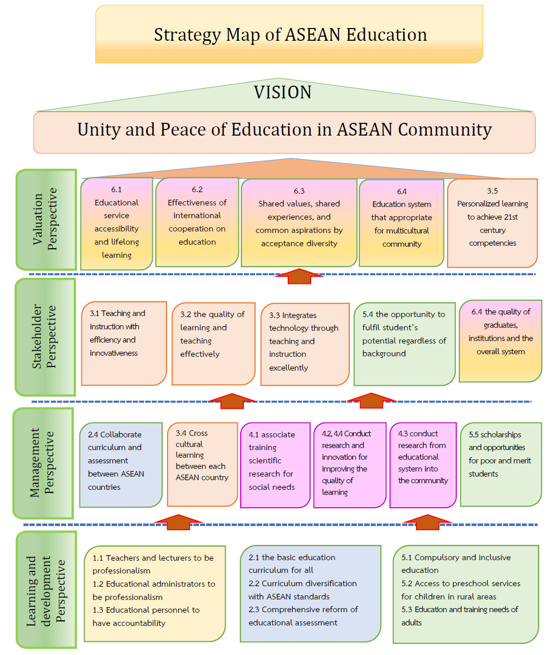
Figure 2 Strategy Map of ASEAN Education

3. The Scenario Writing of Educational Management in ASEAN Community
The scenario was shown in ASEAN education roadmap to predict the future of education that to move towards education cooperation in 2018, to be a unity in education in 2020, to have education for peace in 2022, and to make ASEAN community full of unity and peace of education in 2024 as below figure.

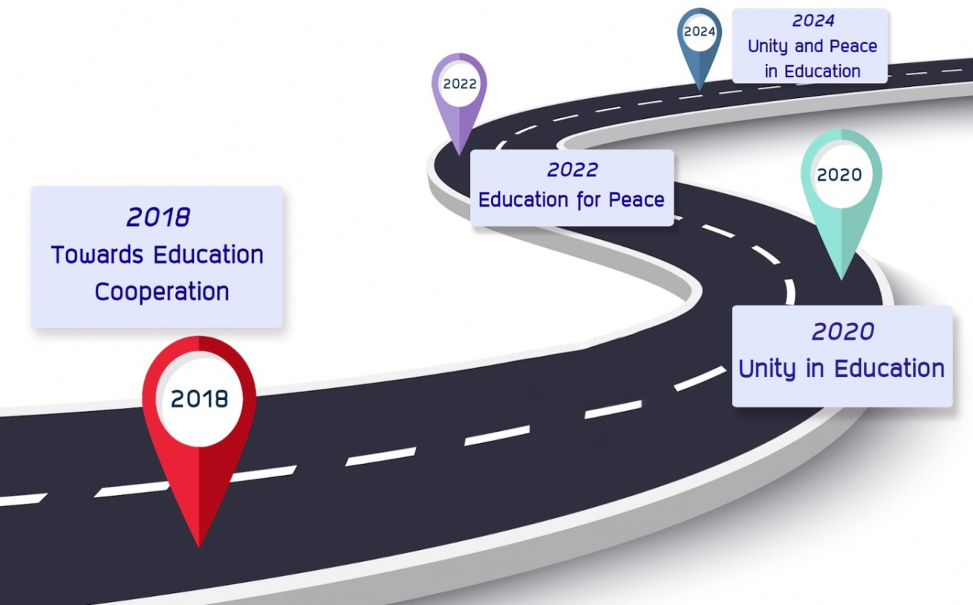

Figure 3 ASEAN Education Roadmap 2018-2024

The Reflection of Research Results
The Reflection of research results has proposed in this chapter including results of study into practice, and lesson learned of field study in ASEAN countries. Details are shown as below.
Reflection
The first reflection related to educational management in ASEAN community showed that ASEAN needs to set up the standard for ASEAN education and the policy of ASEAN education including the identity as the international collaborative project. These results related to the research of Phra Komsaeng Kuntasiri (2012) conducted research entitle “Teaching and instruction on profession curriculum of Pak Pa Sak Technical College, Vientiane, Laos PDR and the suggestion from research encourage teachers to teach and focus on practice more than on theory. Students should be encouraged to have the opportunity of sharing opinion as well as in educational media that teachers should learn more and update new learning media. In the assessment aspect, teachers should give students mark or score without bias. For problem solving indicated that the curriculum should improve to reach the standard by extend to Master degree and Doctoral degree and should develop diverse activities. In addition, teachers should pay responsibility on teaching and focus on activities by supporting students on using educational media such as computer, VDO, picture, newspaper and journal. For the assessment, it should encourage students to ask question during doing class activities. These results also correlated to the strategies of Laos PDR which are the 1st strategy is to encourage education cooperation for developing human resources, the 2nd strategy is to encourage cooperation in knowledge enhancing for teachers and educational personnel in basic education, vocational education, non-formal education and informal education, the 3rd strategy is to encourage cooperation in development and education standard enhancement in higher education from the research of Bureau of International Cooperation (2009) as well as the strategic plan of Cambodia from the same research team found that the 1st strategy is to encourage education cooperation for being the mechanism of making relationship and cultural understanding, the 2nd strategy is to encourage education cooperation for being the main key in human resources development and skill for solving poverty, the 3rd strategy is to encourage cooperation in education reform. These are the sample education strategic plan from ASEAN countries that have tries to develop education in their countries in order to reach ASEAN standard.
The second reflection on strategies of educational management for peace in ASEAN community has shown six strategic aspects consisted of strategy 1 develop teachers and administrators, strategy 2 collaborate curriculum and assessment, Strategy 3 enhance teaching and instruction, strategy 4 encourage educational research, strategy 5 facilitate educational opportunity, and strategy 6 develop educational management. It can be discussed these results are related to the research of Bureau of International Cooperation (2009) which conducted the research called “Strategic Development of Educational Cooperation between Thailand and Neighboring Countries” consisted of Cambodia, Laos PDR, Myanmar and Vietnam. The main strategic plan showed that the 1st strategy was to enhance the policy of educational cooperation to be the national policy for being a mechanism in creating sustainable relationship between Thailand and Neighboring countries. The 2nd strategy was to expand the cooperation of educational quality development in basic education, higher education, vocational education to be lifelong education that related to trend of national development of each country. The 3rd strategy was to create unity in educational cooperative movement with neighboring countries in the same direction. The 4th strategy was to encourage good understanding, trust and confident between Thailand and Neighboring countries. In addition, these results also related to the research of Ministry of Education (2006) from the research called “Comparative research on educational reform of countries in ASEAN community”. Results indicated that all ASEAN countries has given education for the most important issue of country development especially education can lead to economic development. Many countries in both old member and new member still give the role of education to reduce poverty and move over underdeveloped country in economy. At the same time, education is the key of potential enhancement for competition at international level. Some countries in ASEAN wish to have equally potential development within ASEAN countries.
The third reflection related to five goals of the 5th strategy to facilitate educational opportunity, which are 1) support compulsory and inclusive education, 2) expand access to preschool services for children in rural areas, 3) increased attention to the education and training needs of adults, 4) provide the opportunity to fulfill student’s potential regardless of background, and 5) increase scholarships and opportunities for poor and merit students. This strategy is very important for education development for making the unity in ASEAN community. Education for all is a key for providing education opportunity for children who are ASEAN members. It related to the article of Simpson, R.L. and others (2004) studied about “The No Child Left Behind Act Challenges and Implications for Educators”. It showed that The No Child Left Behind (NCLB) Act is potentially the most significant educational initiative to have been enacted in decades. Among the salient elements of this initiative are requirements that all students have qualified teachers and be given the opportunity to attend high-quality schools. The NCLB legislation also requires that states raise academic achievement levels for all students, including those with disabilities. Linked to these components and related issues, this article discusses the major components of the NCLB along with implications and recommendations for educators. For the expectation of this research, researchers hope that we can apply The No Child Left Behind (NCLB) Act to be a part of educational management in ASEAN countries.
The fourth reflection Related to the Encouragement of our ASEAN countries on education development. From the result showed that some ASEAN countries still need further development in term of resources and budget of educational development which related to the report of Department of Foreign Affairs and Trade (2014) on Australia-Laos Education Delivery Strategy 2013–18. Result showed that the focus of Australia’s support will be in improving access to education, through both physical infrastructure and investments in school communities and administrations, to enable better management of resources. For physical infrastructure, support will focus on improving early childhood education learning environments and incomplete primary schools. This support will be carefully planned and managed to ensure it responds to location-specific needs, taking into account resettlement and safeguard concerns; and is matched with resourcing of teachers and learning materials. To complement the physical investment in school communities, efforts will be made to improve the knowledge and value of education in communities. Support for strong school leadership, through capacity building of school principals, Village Education Development Committees (VEDCs), community groups, and District Education and Sports Bureaus (DESBs) will aim to increase community participation in education, ultimately supporting more children to stay in school and complete a basic education. This support will also assist school communities to be better able to plan, manage and more equitable and adequate school resourcing. Australia’s support under this pillar will aim to achieve the following by 2018; 1) increased number of classrooms constructed through a community-based contracting approach in remote and disadvantaged village, and 2) increased number of accessible textbooks and teaching materials that incorporate relevant curriculum distributed to more schools.
In addition, this research results also related to the report of The Ministry of Education, Youth and Sport (2014) which indicated that the fact of ASEAN integration in 2015 and the desire of Cambodia to be a middle income country by 2030 require considerable investment in education. Both professional and well qualified human resources and financial resources are required (highly successful ASEAN countries have grown in part as a result of the high level of education investment often in excess of 5% of gross domestic product GDP). MoEYS recognizes the importance of making the whole of the sector work together in order to respond to the social and economic demands. The focus of the ESP 2014 - 2018 is on consolidating the gains already made in the previous ESP periods, reaching out to the most disadvantaged, providing learning that is of a high quality and relevant to the national development. Education services are delivered professionally and accountably in order to lay a foundation for knowledge and skills based economy. The sector will develop its sector wide quality assurance framework based on learning and service delivery standards that respond to the needs of children, communities and the labor market. Three policies are set for educational management in Cambodia by the year 2018. In Policy 1, Ensuring equitable access for all to education services All children have access to all type of ECE services, primary schools, secondary schools and then opportunities to continue learning. For children who are unable to access formal education alternatives will be provided. Increase the number of children and youth that have access to all education levels with a focused attention on equity and access for the most disadvantaged areas and groups of children. Increase opportunities for children to finish 12 years education with a good knowledge and reasoning and logic skills who can build these skills and knowledge through technical training, higher education and other means. In Policy 2, Enhancing the quality and relevance of learning all children and youth have a relevant and quality learning experience enabling them to contribute effectively to the growth of the nation. Ensure learning is of high quality and relates learning to socio-economic goals of the country and of local contexts; a quality framework that provides learners, parents, communities, teachers and managers with outcome standards and monitoring and reporting against these. In Policy 3, Ensuring effective leadership and management of education staff at all levels Education services are provided effectively and flexibly. Efficient and professional management provides best value (with a focus on results), timely and relevant monitoring and reporting of results with effective feedback, measures for accountability and mechanisms for adjustment to policy, strategy and programs at both national and subnational level. Management of public education institutions can respond efficiently to emerging needs at school level.

Results of Study into Practice
There are three main results of the research finding which can be implemented in the area of education development in ASEAN community.
1. Educational management in ASEAN community showed that most of the educational policy in ASEAN countries depended on the government, the curriculums and instructions focus on child center education and students are trained for 21st century skills, teachers conduct research for solving and developing student’s learning. Teacher training is also an important part of educational development. However, some ASEAN countries still need further development in term of resources and budget of educational development and research.
2. Framework of trends in educational management for the unity in ASEAN community consisted of 5 aspects which were 1) the curriculum of humanism which supported the harmonization and collaboration, 2) the strategic planning came from local people, 3) teaching and instruction were integrated between scientific methods and religious methods, 4) the gap of educational problem should be implemented through action research and religious principles, and 5) all religions were integrated for peaceful coexistence consisted of good for human kind, conduct good action, avoid bad action and purify our mind.
3. Trends of educational management for peace in ASEAN community showed 12 aspects of bringing together to be the top in 2030 and can be developed through educational strategies. Six strategic aspects of educational management for peace in ASEAN community were synthesized consisted of strategy 1 develop teachers and administrators, strategy 2 collaborate curriculum and assessment, strategy 3 enhance teaching and instruction, strategy 4 encourage educational research, strategy 5 facilitate educational opportunity, and strategy 6 develop educational management. Analysis results from Ethnographic Delphi Future Research (EDFR) technique indicated that 6 strategies and 26 goals have been accepted the consensus from experts all items which showed that the expert group had correlated agreement on ASEAN education strategic plan. The scenario was shown in ASEAN education roadmap to predict the future of education that to move towards education cooperation in 2018, to be a unity in education in 2020, to have education for peace in 2022, and to make ASEAN community full of unity and peace of education in 2024.

Lesson Learned of Field Study in ASEAN Countries
The experience of doing data collection in ten ASEAN countries included Myanmar, Laos, Vietnam, Cambodia, Malaysia, Indonesia, Singapore, the Philippines, Brunei Darussalam and Thailand had gained the knowledge of the neighboring countries and to illustrate the locations, cultural sensitivities, unplanned situations, networking strategies, and outcome from field study in order to have deeply understanding to each other in the contemporary pluralistic society in ASEAN community. The overall finding showed that education system in ten ASEAN countries have shown the same system which are the system of pre-school, primary school, secondary school, and higher education. Most compulsory education covers primary school and some countries cover secondary school. Education for all is the main purpose of ASEAN countries in order to develop students to reach the highest potential of their learning.

Conclusion
Education system in ten ASEAN countries have shown the same system which are the system of pre-school, primary school, secondary school, and higher education. Most compulsory education covers primary school and some cover secondary school. Education for all is the main purpose of ASEAN countries in order to develop students to reach the highest potential of their learning. Six strategic aspects were synthesized consisted of strategy 1 develop teachers and administrators, strategy 2 collaborate curriculum and assessment, Strategy 3 enhance teaching and instruction, strategy 4 encourage educational research, strategy 5 facilitate educational opportunity, and strategy 6 develop educational management. The result of analysis from Ethnographic Delphi Future Research (EDFR) technique which collected from 27 experts found that 6 strategies and 26 goals have been accepted the consensus from experts all items.

References

Department of strategy and evaluation Bangkok. (2013). Knowledge of ASEAN community. Bangkok: National Office of Buddhism Publishing.
Department of Technical Education. (2008). The role of technical and vocational education training (TVET) providers in training for employees. Information paper on Brunei Darussalam for APEC Forum on Human Resource Development, 19-21 November 2008, Chiba City, Japan.
Editorial department. (2011). Enhancing education by using technology into the world level. Wittayajarn Journal. 110 (11) (September 2011): 73-74.
Florido, A.M. (2014). Educational profile of the Philippines and best practices in Filipino schools and classrooms. Retrieved on 25th October 2015, from http://www.unc.edu
Khaemanee, T. (2007). Teaching Science: Knowledge for efficient learning procedure. 2nd edition. Bangkok: Chulalongkorn University publisher.
Ministry of Education. (2012). The Ministry of Education Strategic Plan 2012 – 2017. Retrieved on 9th October 2017, from http://www.moe.gov.bn/ Shared%20Documents/strategicplan.pdf
________. (2014). Education strategic plan 2014 – 2018. Retrieved on 25th October 2014, from http://planipolis.iiep.unesco.org
________. (2006). Comparative research on educational reform of countries in ASEAN community. Bangkok: Office of the Education Council.
Phra Komsaeng Kuntasiri. (2012). Teaching and instruction on profession curriculum of Pak Pa Sak Technical College, Vientiane, Laos PDR. Thesis of Master Degree on Educational Administration. Graduate School, Mahachulalongkornrajavidyalaya University.
Piboonsongkram, P. (2011). Create the connection in ASEAN for the usefulness of Thai people. ASEAN Hightlight, pp 50-53, Retrieved 22 October 2018, From http://www.mfa.go.th/ asean/contents/files/asean-media-center-20121204-122503-499440.pdf
Pornsrima, D. (2013). Critical and opportunity of Thai teaching career forward to ASEAN community. An Academic Conference of Kurasapa in 2013 on “Research for enhancing educational quality and professional development”, on 14-15 September 2013 at Ambassador Hotel, Sukhumvit 11 Bangkok.
Simpson, R.L., Lacava, P.G. & Graner, P.S. (2004). The No Child Left Behind Act Challenges and Implications for Educators. Sage Journals. 40(2), (November 1, 2004): 67-75.
The World Bank. (2014). Education in Indonesia: Managing the transition to decentralization. Retrieved on 25th October 2018, from http://siteresources.worldbank.org/EDUCATION

Curriculum Vitae
Assoc. Prof. Dr. Phra Theppavaramethi, Vice-Rector for Administration, Mahachulalongkornrajavidyalaya University. Graduated in Doctor of Philosophy (Ph.D.) in Philosophy, University of Madras, India and received Scholarship from India Government (UNIVERSITY GRANTS COMMISSION: U.G.C.). Current address is Wat Prayurawongsawas Warawihan, Khaeng Wat Kalaya, Thonburi, Bangkok 10600. He also serves the Sangha Supreme Council of Thailand as Secretary to the President of Sangha Council Region 2 and the Vice-Abbot of Wat Prayurawongsawas. Over 2 decades, he took a leading role in organizing the International Cerebration on the Occasion of United Nation Day of Vesak to advocate Dhamma applications and sufficiency practices. Phra Theppavaramethi is the author, coauthor or editor of more than 100 books, including Buddhist Ethics in the World of Impermanence and Life History and Achievements of Phra Upalikunupramajarn. His recent work focuses on ASEAN related issues. He is also conducting an international research on the development of integrated Buddhist ASEAN Curriculum in Thailand and CLMV Countries funded by Thailand Research Fund (TRF) and Buddhist Research Institute of MCU.

Curriculum Vitae (Presenter)
Dr.Lampong Klomkul is a researcher and director for research, information and academic services division, ASEAN Studies Centre, Mahachulalongkornrajavidyalaya University. She Graduated in Doctor of Philosophy (Ph.D.) in Educational Research Methodology, Faculty of Education, Chulalongkorn University, Thailand. She received award from National Research Council of Thailand: The best dissertation of year 2013 in Good Level (Education Field), received Graduate Scholar Award from The Nineteenth International Conference on Learning, The Institute of Education University of London, London, UK, August 14-16, 2012. She also received Golden Jubilee Scholarship to study in Canada for two years in Bachelor degree from 1997-1999. She is interested in conducting classroom action research, and to conduct research on teacher’s development. In addition, she is interested in conducting research on applied Buddhist Studies into education and culture in ASEAN Community.
Contact: E-mail: research.mcu@gmail.com, Tel. +66 92 251 1212

